August 30, 2019

Administrator Andrew Wheeler
Environmental Protection Agency
1200 Pennsylvania Ave. NW
Washington, DC 20460

RE: Docket ID EPA-HQ-OAR-2019-0136

Dear Administrator Wheeler:

Illinois Corn Growers Association (ICGA) appreciates the opportunity to provide comments on the proposed rule for the 2020 volume standards under the Renewable Fuel Standard (RFS) program. We represent more than 4,000 corn farmer members throughout Illinois who rely on our association to help them build and preserve markets for the ever-increasing amounts of corn grown in Illinois each year.

ICGA feels that any volume proposed by the EPA through this process lacks certainty. While Illinois farmers are grateful for the surface effort to increase volumes of total renewable fuel volumes used, EPA’s past action to authorize small refinery waivers and decrease the market opportunity for renewable fuels speaks volumes.

This is a case where actions speak louder than words. The RFS waivers have more than outpaced the offered increased volumes set in the RVO, leaving the ethanol industry throttled and Illinois farmers without market opportunities.

ICGA also disagrees with the proposal to retain 2016 RFS volumes, after being court-ordered to restore the 500 million gallons in this 2020 rule.

The Illinois Corn Growers Association would lend our support to the comments submitted by the National Corn Growers Association dated August 30, 2019. Their comments detail all the actions EPA has taken to halt the growth of the renewable fuels industry, sacrificing cleaner air, cost-savings for consumers, and opportunities for rural economic growth.

Sincerely,

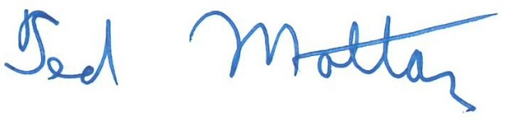
Ted Mottaz, President

1k3-9bwe-8f3a

