November 21, 2018

U.S. Environmental Protection Agency
Office of Pesticide Programs
1200 Pennsylvania Ave. NW.
Washington, D.C. 20460-0001

Re: Draft Human Health Risk Assessments for Atrazine; Docket ID Nos. EPA-HQ-OPP-2013-0266-1161

Illinois Corn Growers Association appreciates the opportunity to provide comments supporting the continued use of atrazine. We represent more than 4,000 corn farmer members throughout Illinois who all rely on the latest and most up-to-date technology to sustainably manage the roughly 27 million acres of farmland, covering about 75% of our state. These farmers need every available tool to manage insect and weed infestations and grow enough grain to feed and fuel our world.

We understand that atrazine is one of the most extensively studied, reviewed and regulated agricultural products in the world. We also understand that farmers rely on atrazine to control weeds, enable no-till farming, and manage ever growing weed resistance issues.

Given the extensive research of this product and the extreme need for this product to produce sustainable food, it is difficult to understand the EPA’s continuous review.

The draft human health risk assessment updates more than a decade of careful, detailed, and scientifically comprehensive reviews that are an acknowledgment of atrazine’s safety when used according to the label.

Thank you for this opportunity.

Sincerely,

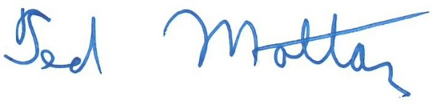
Ted Mottaz, President

1k2-96oh-xjeh

