NEONICOTINOID INSECTICIDES: What EPA needs to know!
Good for farmers, good for communities, good for the economy

Background
Introduced in the mid-1990s, neonicotinoid insecticides have become one of the most important tools used in agriculture and the largest selling insecticide class in the world. Commonly called “neonics,” they can be used on many crops as a seed treatment, foliar spray or soil application. However, most neonics – more than 90 percent — are used to treat seeds to protect them from destructive insects that hide below ground.

A comprehensive, 16-report study by AgInfomatics, released in 2014 and 2015, showed neonicotinoid insecticides increase crop yields, add billions of dollars to the economy and benefit entire communities, not just farmers. The research reports, along with news releases, fact sheets, infographics and videos, are available at GrowingMatters.org.

Registration review
Neonicotinoids are currently undergoing registration review, an extensive scientific process that the EPA conducts on all registered pesticides every 15 years, to ensure they meet the latest scientific standards. This multistep process typically takes five to eight years to complete.

EPA plans to review all neonics in the same timeframe to ensure consistency across the class. As risk assessments are completed, the Agency will pursue steps to mitigate potential risk, as appropriate.

Active Ingredient (a.i.)  & Docket Number | Planned  Completion | Open Dockets for Comment  (Closing on April 21, 2018)
Imidacloprid  EPA-HQ-OPP-2008-0844 | 2018 | - Transmittal of the Preliminary Terrestrial Risk Assessment to Support the Registration Review  - Benefits of Neonicotinoid Insecticide Use in the Pre-Bloom and Bloom Periods of Cotton (All Neonics)  - Benefits of Neonicotinoid Insecticide Use in the Pre-Bloom and Bloom Periods of Citrus (All Neonics)
Clothianidin  EPA-HQ-OPP-2011-0865  Thiamethoxam  EPA-HQ-OPP-2011-0581  Dinotefuran  EPA-HQ-OPP-2011-0920 | 2018 | - Occupational and Residential Exposure Assessment for Registration Review.  - Drinking Water Exposure Assessment for Registration Review of All Registered Uses  - Draft Human Health Risk Assessment in Support of Registration Review.  - Acute and Chronic Aggregate Dietary (Food and Drinking Water) Exposure and Risk Assessments for Registration Review  - Transmittal of the Preliminary Aquatic and Non-Pollinator Terrestrial Risk Assessment to Support Registration Review

Registration review includes the following neonic brands:
- Imidacloprid – Bayer’s Admire® Pro, Gaucho® (600, XT), Leverage360, Velum® Total.
- Clothianidin – Bayer’s Poncho®, Poncho®/VOTiVO, Poncho® Beta, Prosper® EverGol®, Sepresto 75WS, Emesto Quantum. Valent’s NipsIt INSIDE®, NipsIt® Suite, INOVATE®, INTEGO®, Belay® Insecticide.
- Thiamethoxam – Syngenta’s Actara®, Platinum®, Cruiser® FS, CruiserMaxx®.
- Dinotefuran – Valent’s Venom® Insecticide.

As part of this multistep process, EPA is now seeking public comments on the current neonicotinoid risk assessments, highlighted in the chart above and posted on the individual a.i. dockets. The dockets will remain open through April 21, 2018.

Your role
Because EPA receives many comments from environmental groups about restricting neonics, it’s important for the Agency to hear from people who actually use these products. As an association leader, consultant and/or grower, you have valuable information that will help EPA understand the importance of neonicotinoids to your operation.
- How many acres do you farm? Where is the farm located? What kinds of crops do you grow?
- How do you use these products: seed treatment, foliar application and/or soil application?
- Why do you use these insecticides? How do they benefit your farming operation?
- If these products were no longer available for use, what effect would that have on how you farm: What other products would you need to use? Would you need to change from seed treatment/soil applications to foliar sprays? Would you need to spray more often, etc.?
- Consider closing with: “We know these are preliminary risk assessments. We trust EPA will refine, as necessary, based on sound science and field data and think through IPM and resistance management requirements.”

To post a public comment, respond by April 21st:
- Please post comments on each a.i. (can be the same comments) by clicking on the correlating docket number in the chart above, i.e. EPA-HQ-OPP-20__-____.
- This takes you to the individual a.i. registration review page (shown below). Then click on the dark-blue box, “Comment Now!”
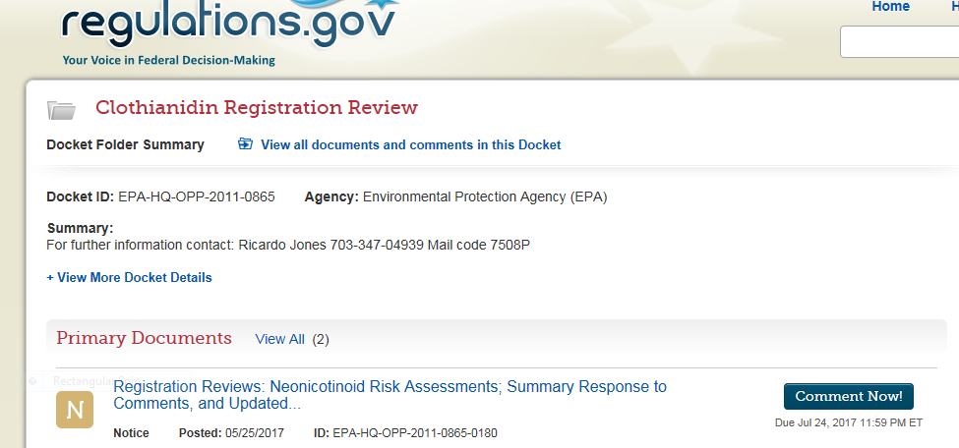

- The next screen shows: “You are commenting on.” Enter comments in box – 5,000 character limit. You have the option of uploading files. When finished, press “Continue” button on bottom right.
- Next, you can preview and edit comments. You must check the box, “I read and understand the statement above,” before you can click “Submit comment.”
- The next page provides a receipt number to verify your comments have been received by EPA.

Thank you for your support.

